Computer Assignment 3-Filtering an ECG Signal

Robert Bara, Zenon Matychak  
robert.bara@temple.edu, tuj21479@temple.edu

# Introduction

The purpose of this computer assignment is to filter out 60 cycle hum noise within an ECG signal by using continuous filtering techniques built in MATLAB.

# Methods

Given an ECG signal sampled at $F_{s}=1000$ samples per second, the sample can be loaded into MATLAB since it is delivered in an ASCII format. From that plotting the ECG signal with respect to time is relatively straight forward, and the frequency of the noise can be examined to be $60$ Hz by taking the Fourier Transform of the signal at $1000$ samples per second by using the myfft function. A 3rd order butterworth filter is then created to filter with a cutoff frequency of $20$ Hz, to allow the signal through while cutting the noise. The transfer function is then upon using MATLAB’s $tf$ function. From the transfer function, lsim can be applied to compare the filtered signal to the original signal and to find Y(t) which will confirm if the noise has been reduced upon taking the Fourier Transform.

# Results

Transfer Function of Filter:

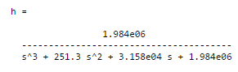

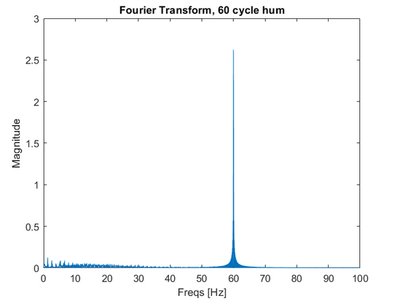

[Figure. Examining the Fourier Transform of the x(t)]

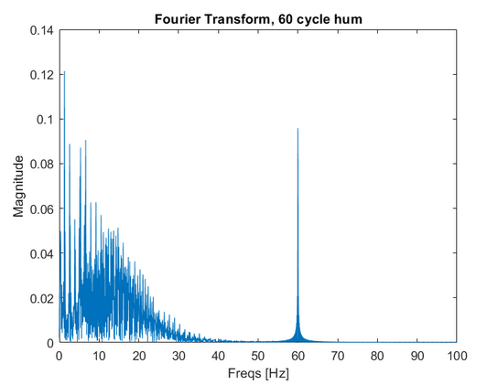

[Figure. Fourier Transform of Y(t)]

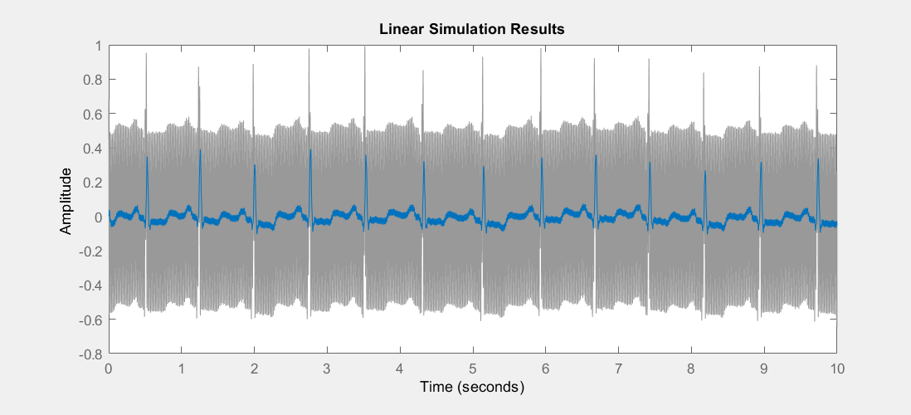

[Figure. Comparing Original Signal in grey vs Filtered Signal in blue]

# Discussion

Upon taking the Fourier Transform, it is apparent that

the noise is a $60$ Hz-cycle hum, and since an ECG signal will measure heartbeats at frequencies below $20$ Hz, the $60$ Hz noise will have to be filtered by a lowpass filter in order to let the lows pass through and cut the higher noise frequency. Knowing that the noise is at $60$ Hz, the cut off frequency should be lower than $60$ Hz so that the noise will be filtered out, but not low enough that it will cut out the lower heartbeat frequencies of the signal. After creating a butter frequency at a cutoff of Hz, using lsim allowed the original signal to be compared to the filtered signal in which the noise is significantly reduced. In conjunction, the transfer function can be found to find y(t) and by taking the Fourier transform of y(t), the noise can be observed to be reduced. A higher order filter may be more efficient because the filter will have a steeper cut. Using a steeper cutoff frequency will allow us to allow more of the original signal through and cutting more accurately, closer towards the higher-nosier frequency.